

E-PROJECT
Aptech Sharah - E - Faisal Center
TEAM MEMBERS:
S.NO | STUDENT ID | NAME
1 | 1644688 | Anas Malik
2 | 1647514 | Anosh John
3 | 1647389 | Stephaine Shakeel

Project: Faculty:
Maru Dry Fruits Miss Aqsa Tabassum

Batch code: Semester:
AI-202503G TTS 1st (Front end)

Brief:
The dry fruits are rich in vitamins and proteins; they also boost immunity and prevent lifestyle diseases such as cholesterol and diabetes. Most dry fruits are rich in minerals, proteins, fiber and vitamins add to that they are tasty and delicious too. Dry fruits are excellent and healthy substitute for daily snacks. Maru dry fruits - a local shop in the market is pretty old and needs website for advertising the products, providing information about them so as to attract more and more customers.

Our Mission:
Our goal is to create a website which will assist the faculty to spread their word
throughout the globe in order to provide their services to the desired ones.

Requirements:
The Web site is to be created based on the following requirements.
1. The home page must be designed with beautiful color combination with all the
required links defined properly. Also all the section of the webpage must be in
used to avoid the blank space.
2. It should include all the variety dry fruits, its rate as per quality.
3. Site should also provide nutrition information about each and every dry fruit.
4. Customer should be able to buy online, quantity as specified by them.
5. The site should display various offers / discounts announced time to time
6. It should also include the festival gift packs.
7. About us, Contact Us, Disclaimer must be included.
8. Contact us page: contact us details with location should be displayed using
GeoLocation API (eg. GoogleMaps).
9. Creating an account facility can also be added.
10. Dummy procedure for buying to be added.
11. Sitemap must be added.
12. Navigation of the project must be made smooth.

Graphical representation of nav-items:

- Home
- Special Deals
- About
- Cart
- Contact

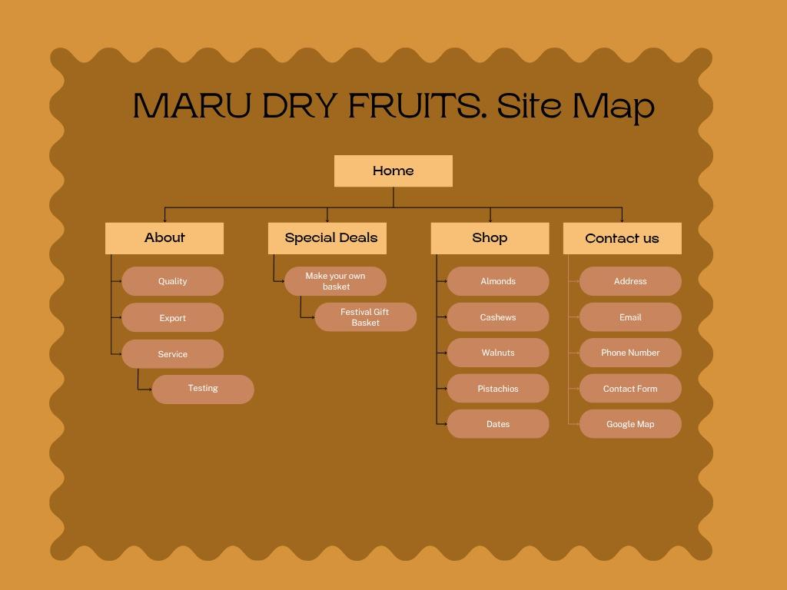

Coding Details
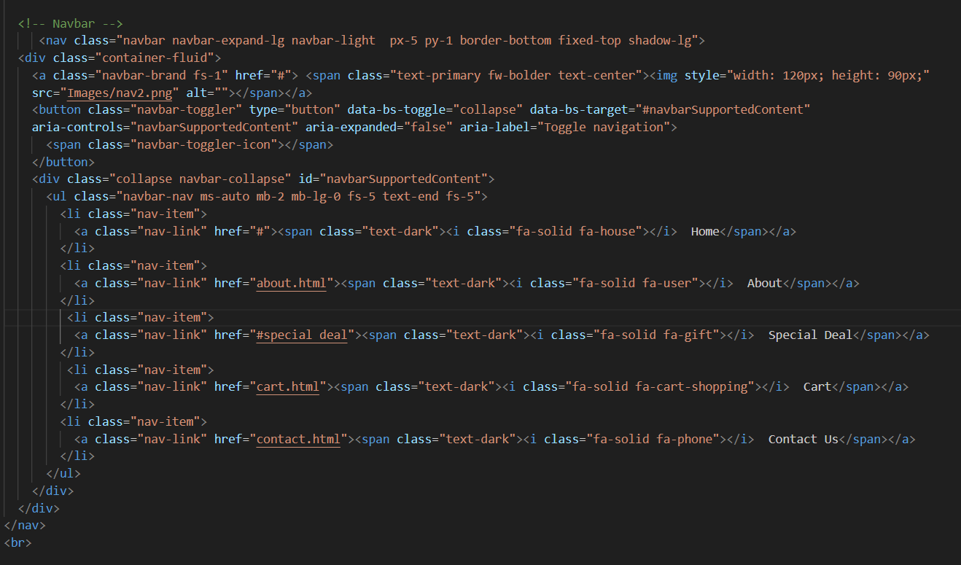
Navbar – HTML & CSS

INDEX – HTML, CSS
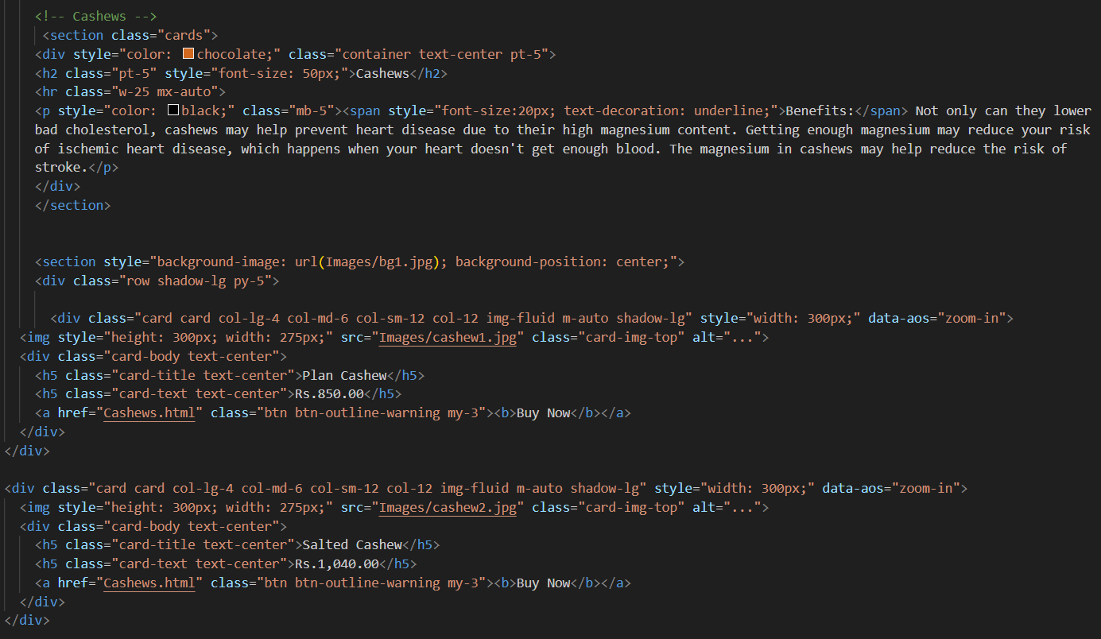

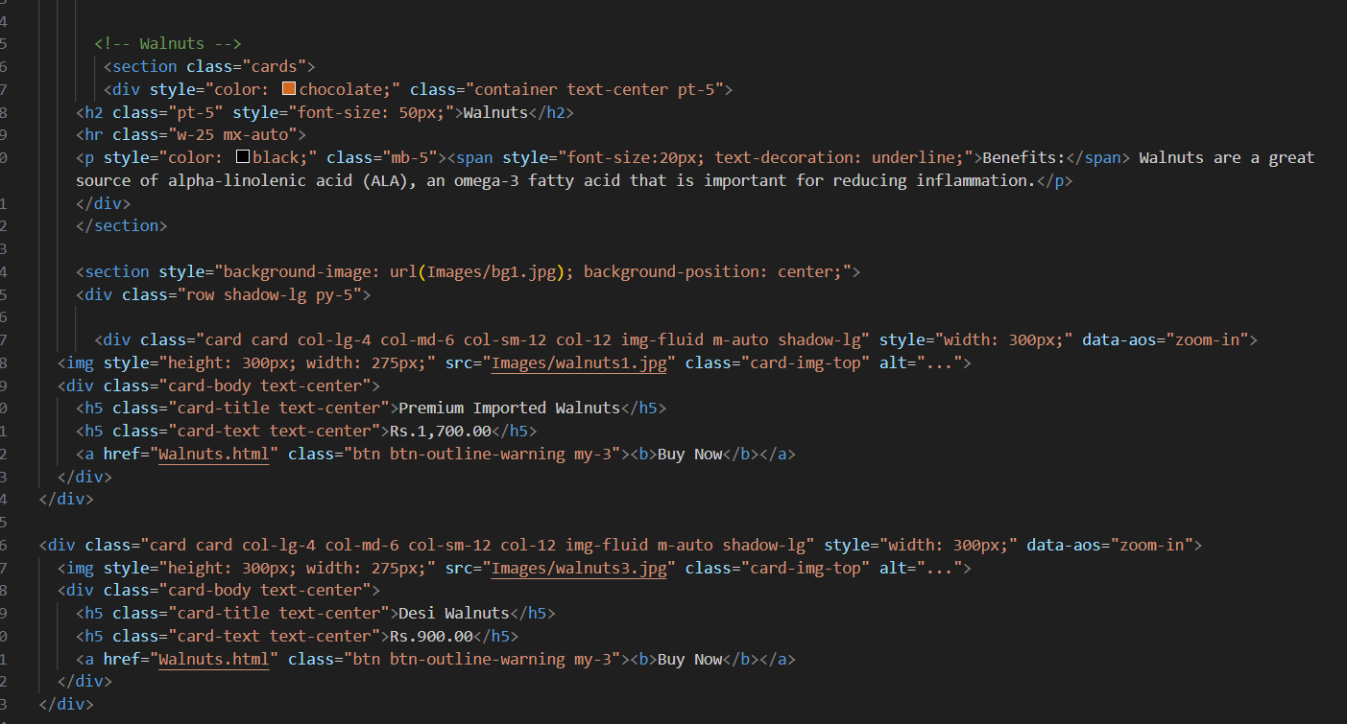

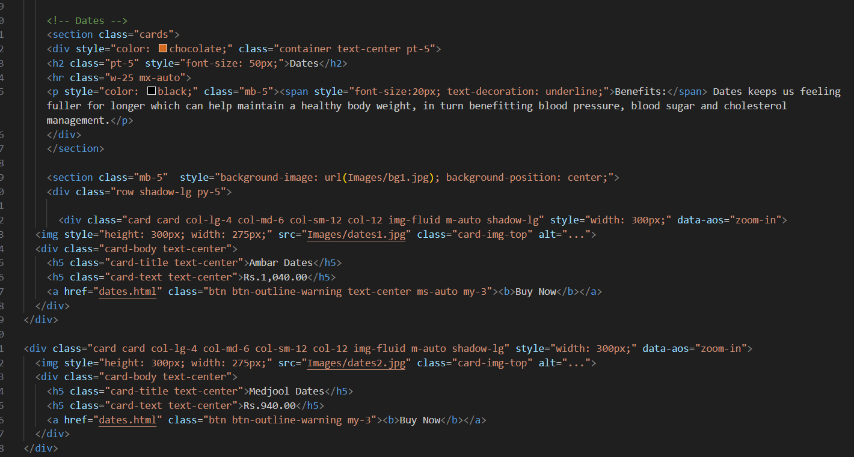

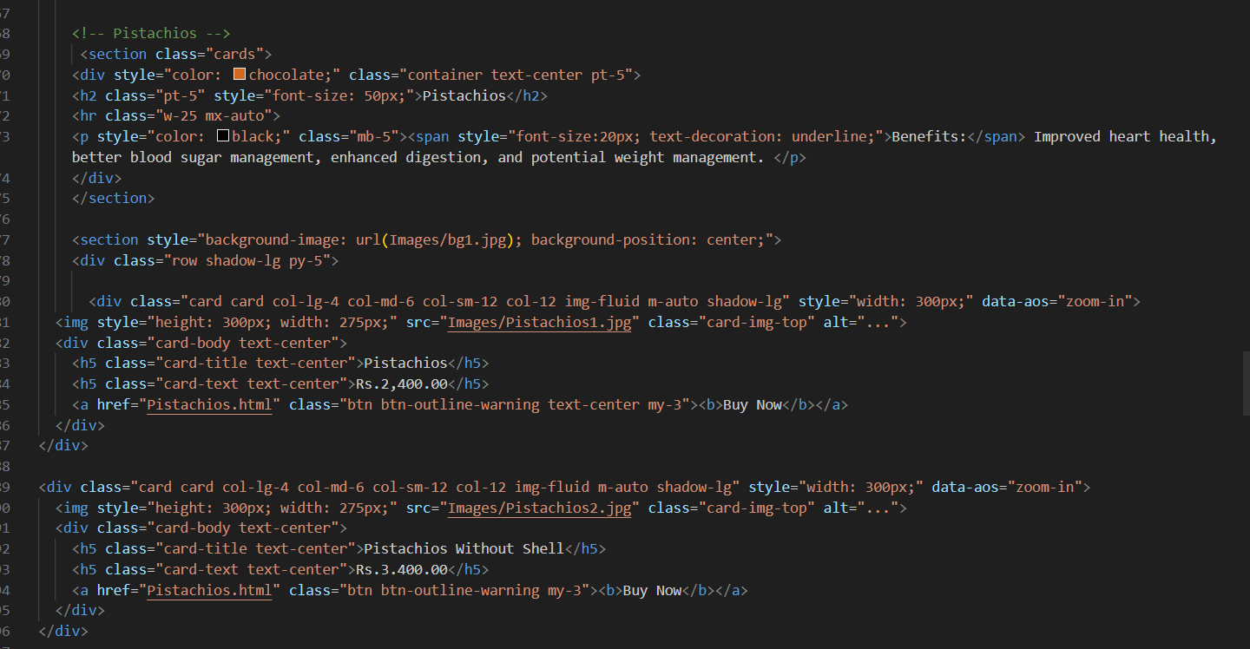

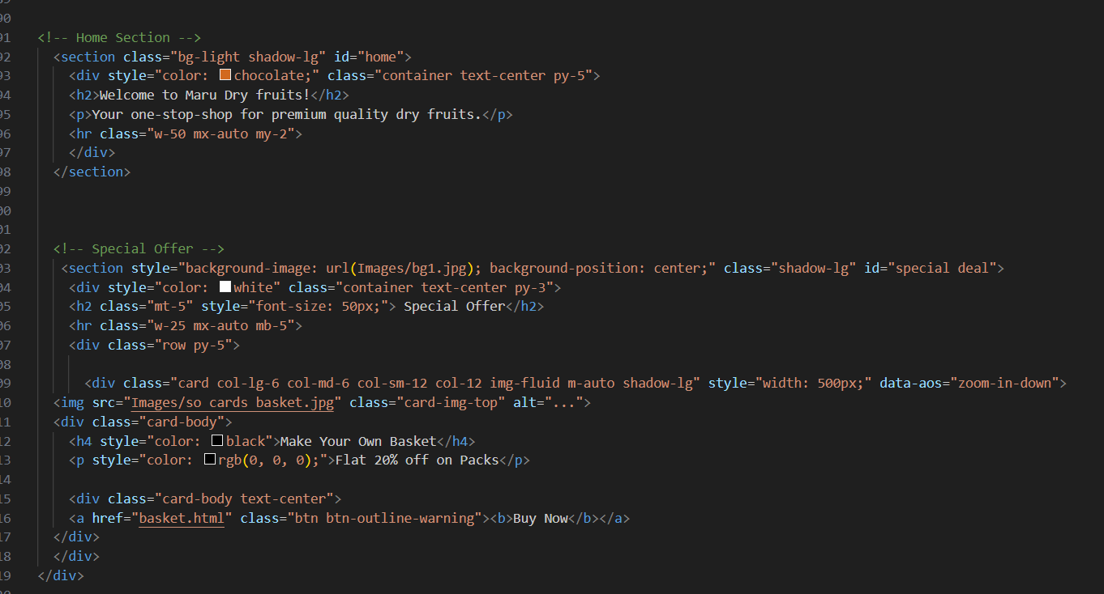

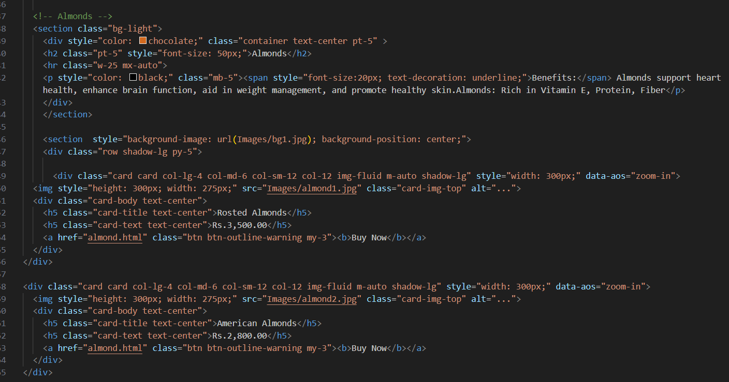
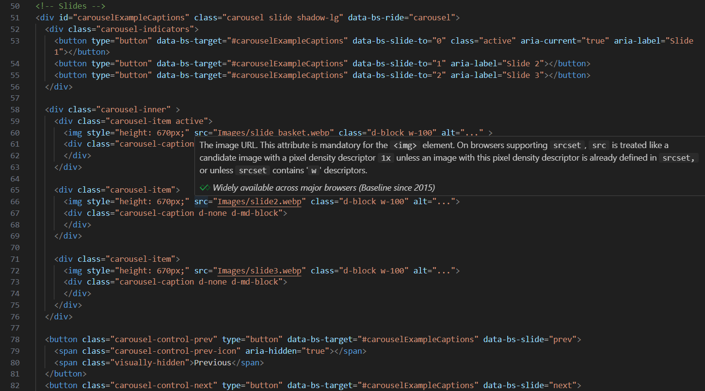

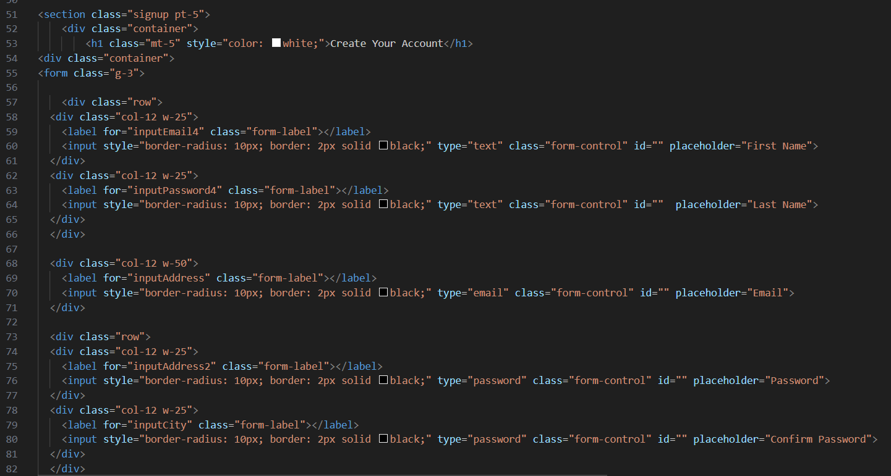
CART – HTML & CSS

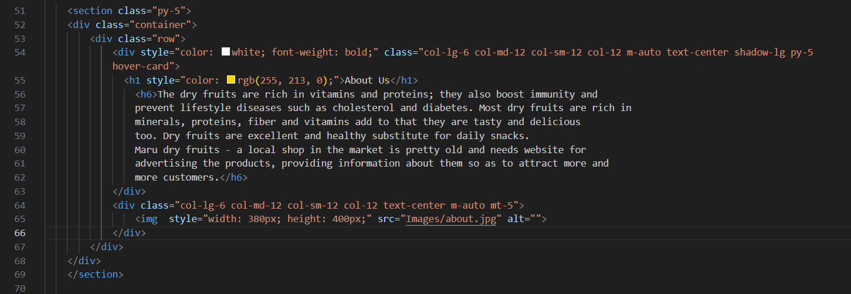
ABOUT – HTML & CSS
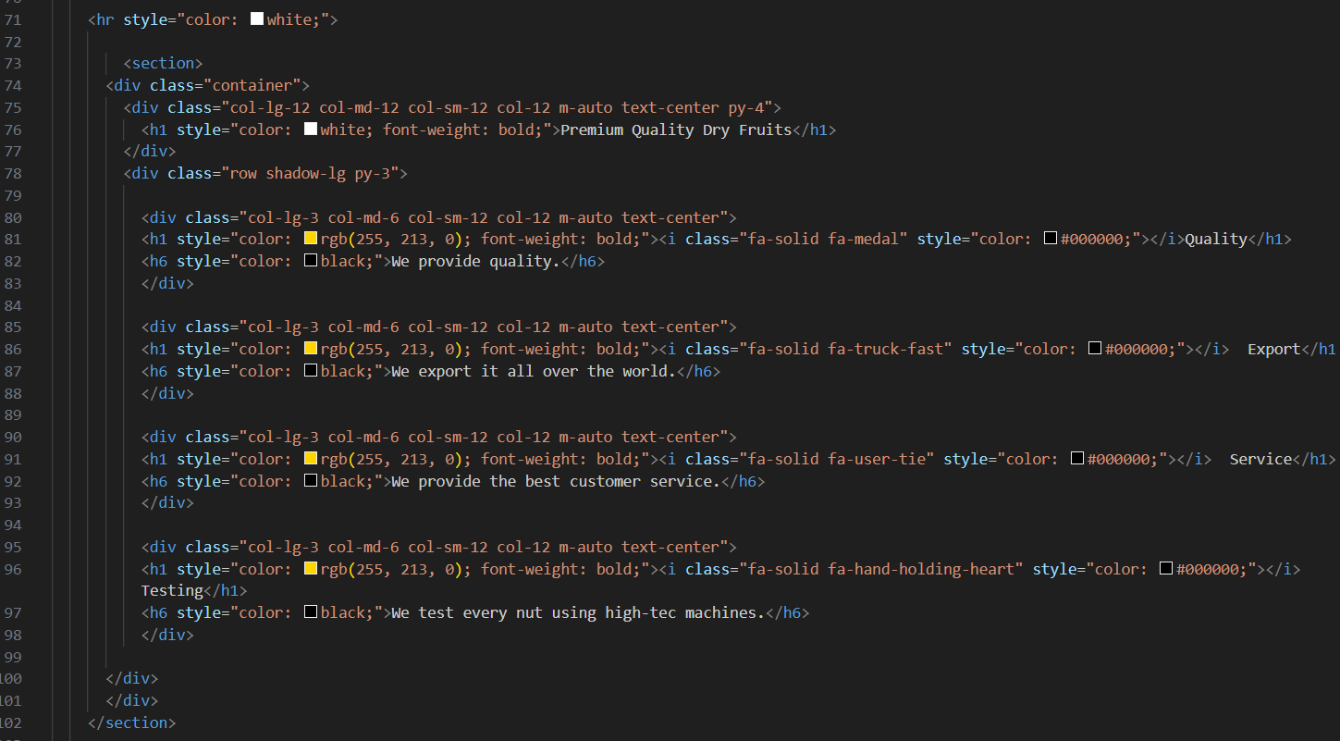

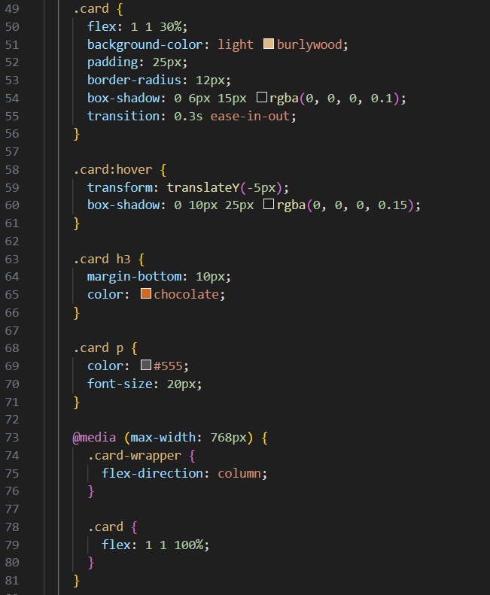
CONTACT – DEAL HTML & CSS
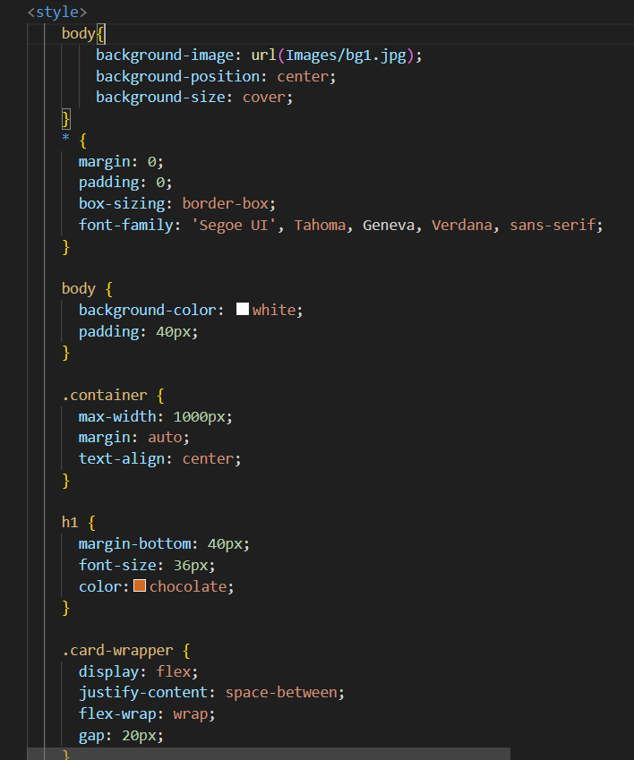

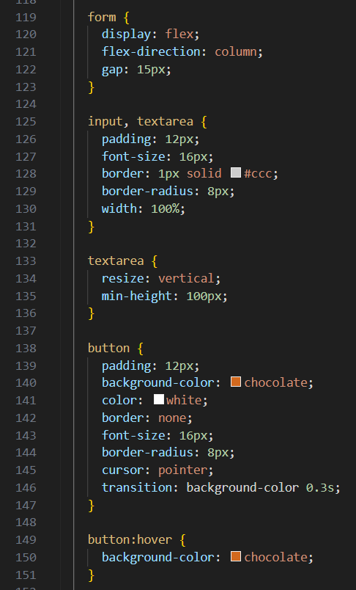
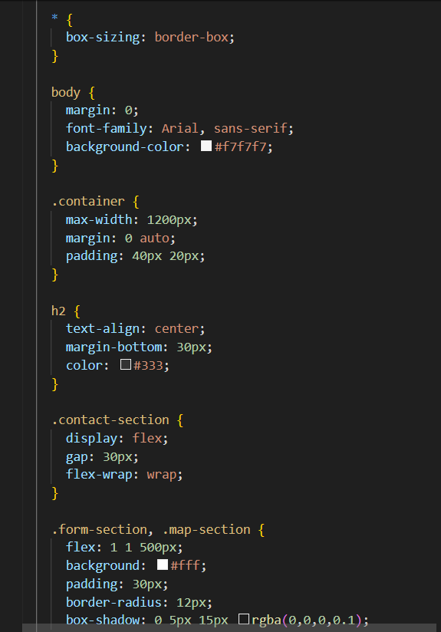

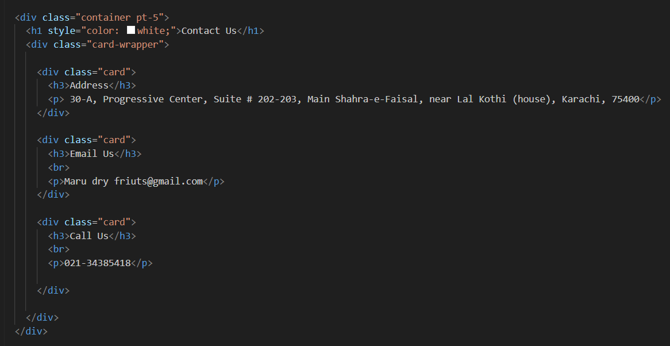

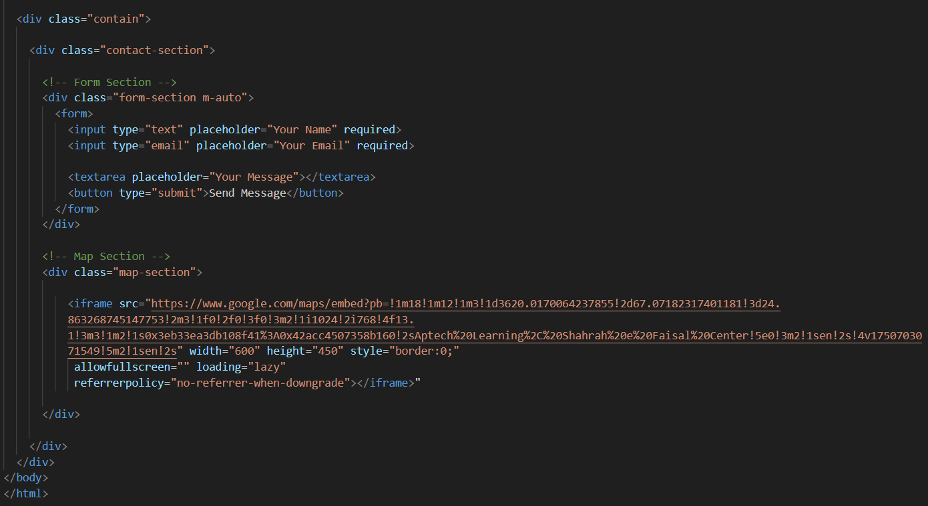
FOOTER – HTML & CSS
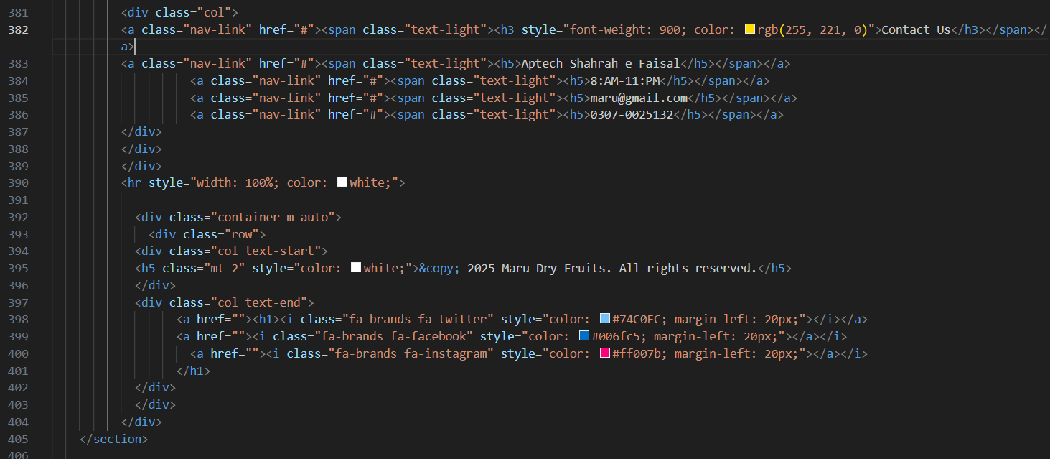
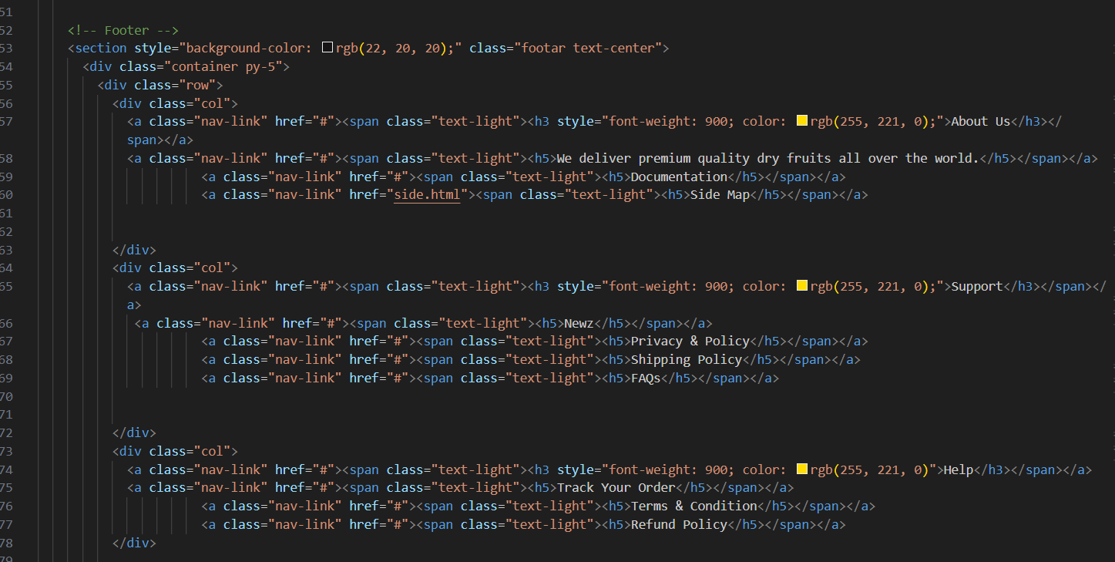

Output
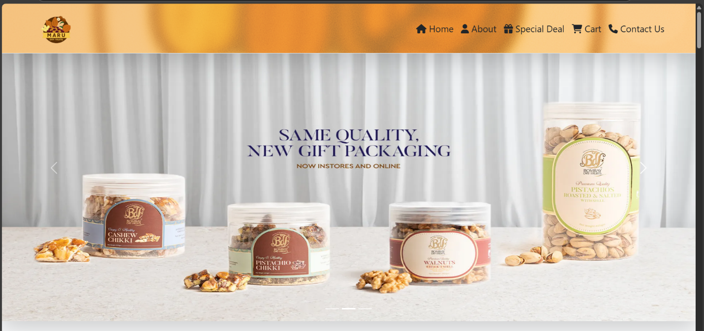
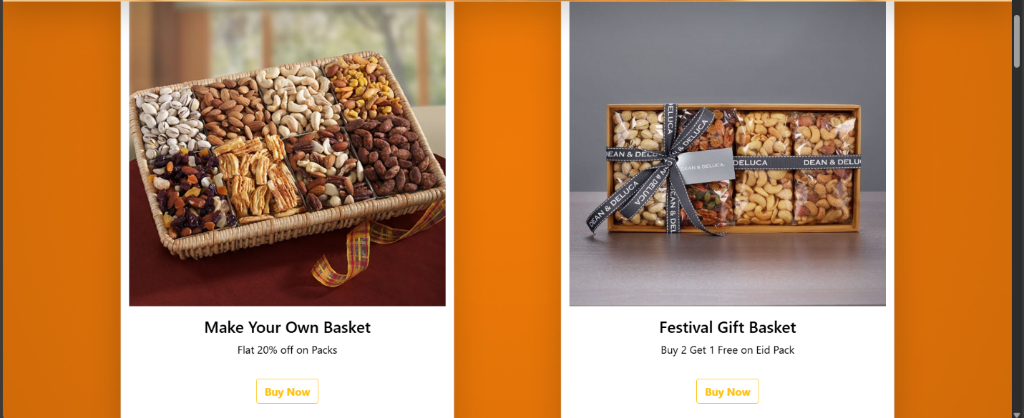
Navbar, Home & Footer

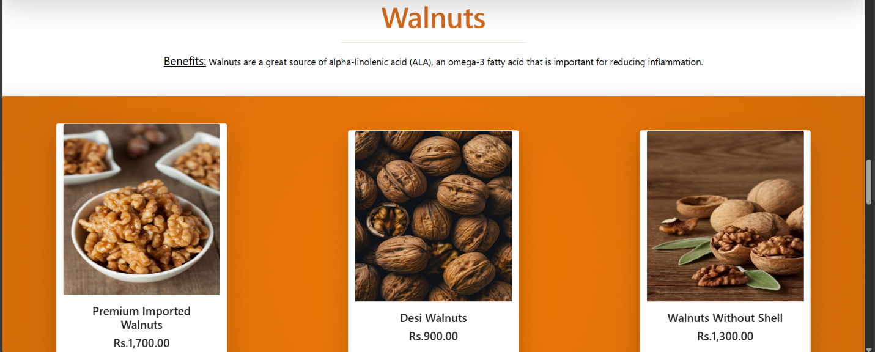
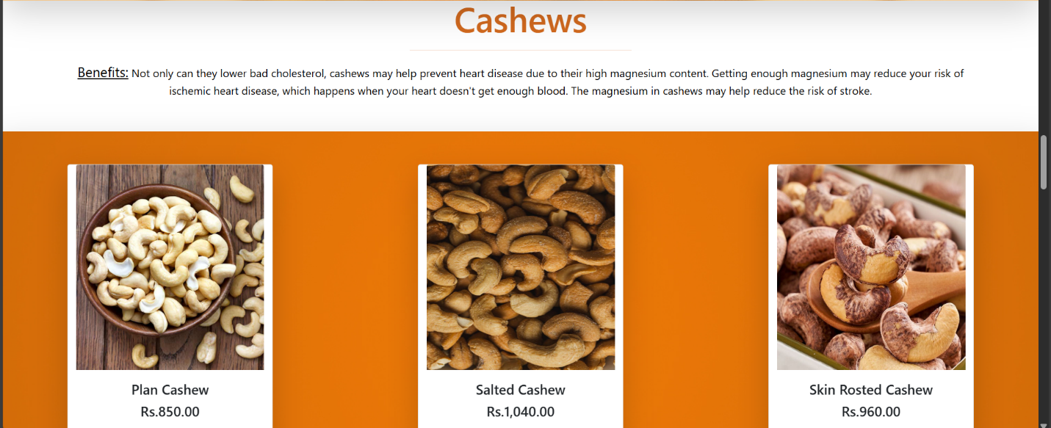
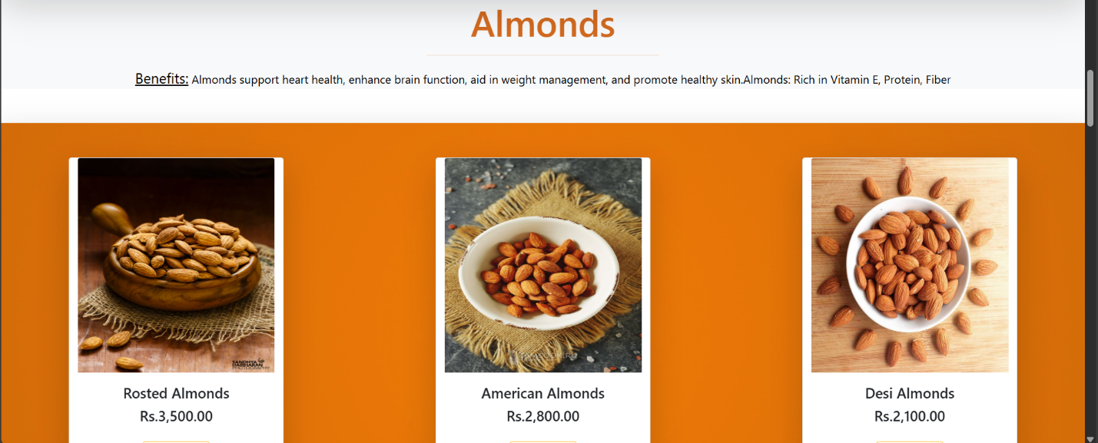
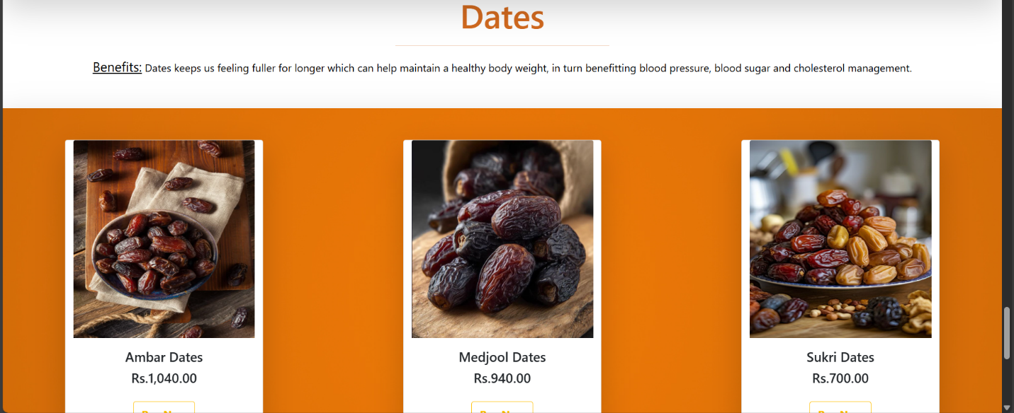
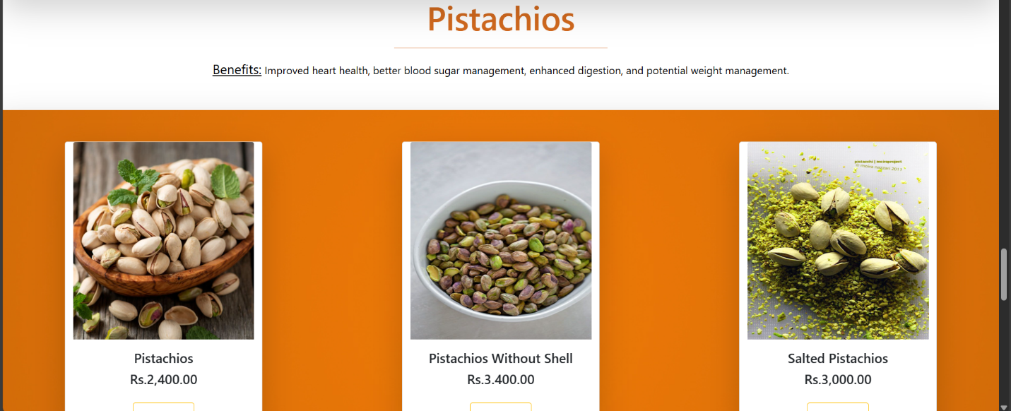
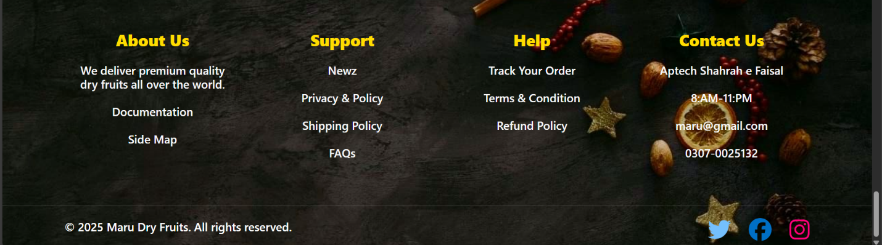
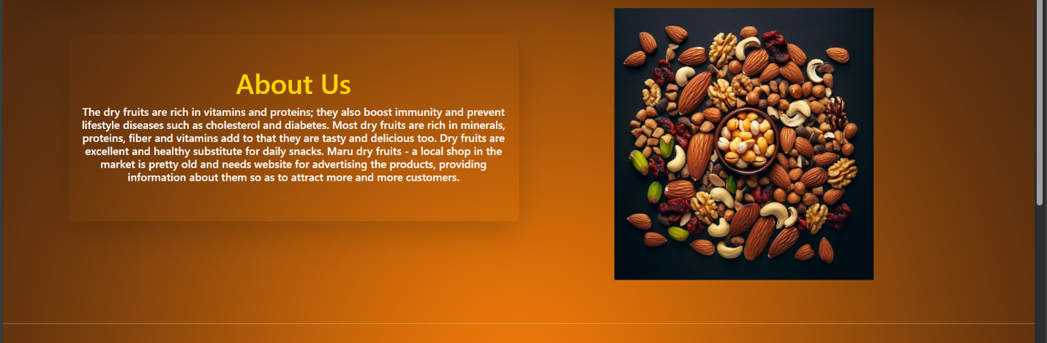
About


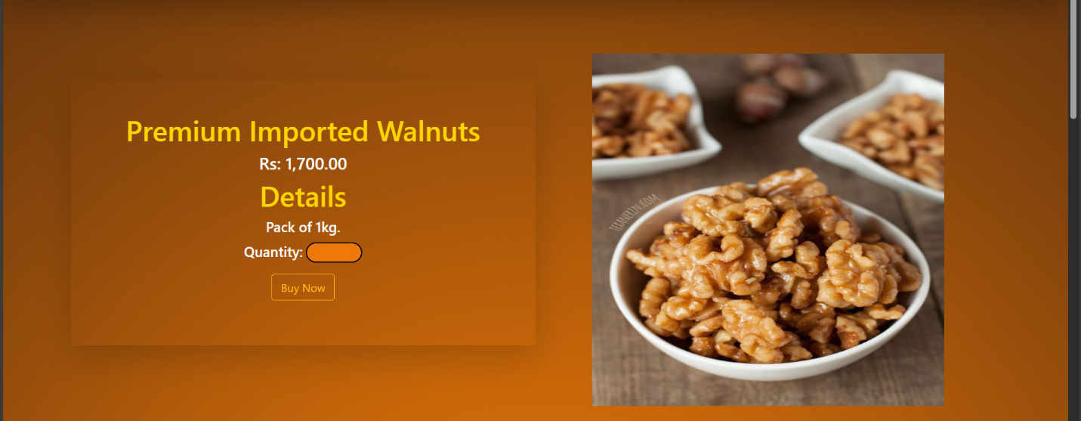
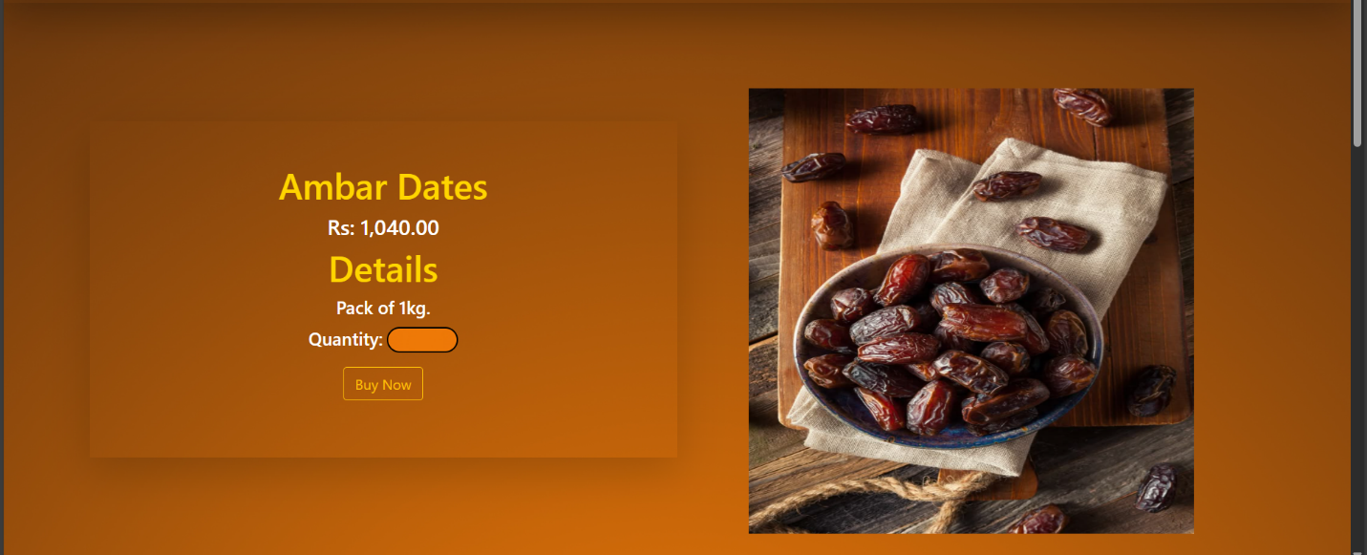
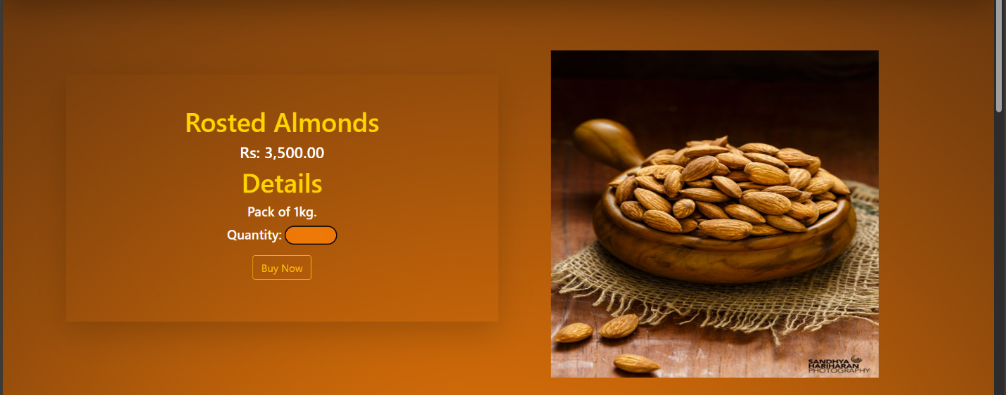
Cart
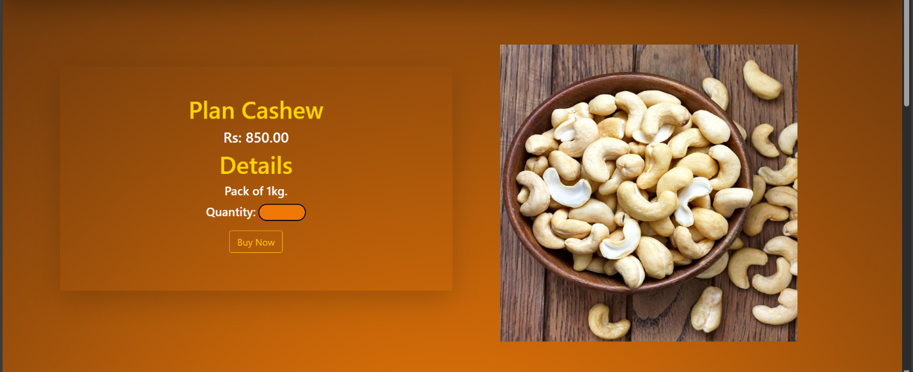
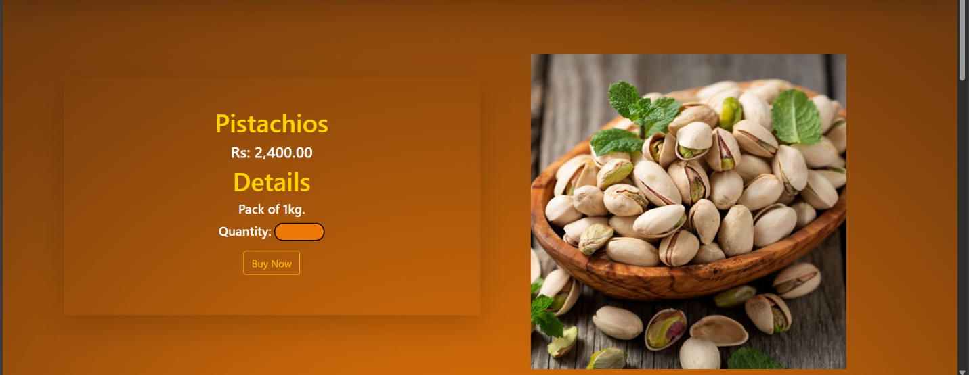

Contact Us

